**MEDICAL INVENTORY MANAGEMENT**

**COLLEGE NAME:**SMS COLLEGE OF ARTS AND SCIENCE

**COLLEGE CODE:**bru4s

**TEAM ID:**NM2025TMID28684

**TEAM MEMBERS:**

**Team Leader Name:**THILAK D

**Email:**[thilakd864@gmail.com](mailto:thilakd864@gmail.com)

**Team Member 1:**GURUDEV S

**Email:**[gdev3118@gmail.com](mailto:gdev3118@gmail.com)

**Team Member 2:**GOLDA JULIETH D

**Email:**[goldajuliethgabi@gmail.com](mailto:goldajuliethgabi@gmail.com)

**Team Member 3:**JOEL JEBARSON R

**Email:**[joeljebarson2005@gmail.com](mailto:joeljebarson2005@gmail.com)

**Team Member 4:**LEEMA ROSLIEN S

**Email:**[leemaroslien@gmail.com](mailto:leemaroslien@gmail.com)

**INTRODUCTION:**

The main objective of building this CRM is to centralize and simplify medical inventory management processes within Salesforce. The system ensures that medical supplies are monitored, allocated, and replenished effectively, minimizing the risk of shortages or overstock. By integrating workflows, automation, and dashboards, it provides business value in the form of enhanced operational efficiency, better visibility, improved compliance, and optimized resource utilization. This enables healthcare facilities to focus more on patient care while reducing manual administrative tasks.

**PURPOSE:**

The purpose of the Medical Inventory Management CRM is to create a centralized and automated system for tracking, managing, and replenishing medical supplies within healthcare organizations. The CRM is designed to minimize manual errors, reduce wastage, and ensure timely availability of critical medical resources. By leveraging Salesforce capabilities such as custom objects, flows, triggers, and dashboards, the system provides accurate, real-time visibility of inventory levels and enables data-driven decision-making. Ultimately, the purpose is to improve operational efficiency, maintain compliance, and support better patient care outcomes by ensuring medical supplies are always available when needed.

**DEVELOPMENT PHASE**

**Creating Developer Account:**

By using this URL - 

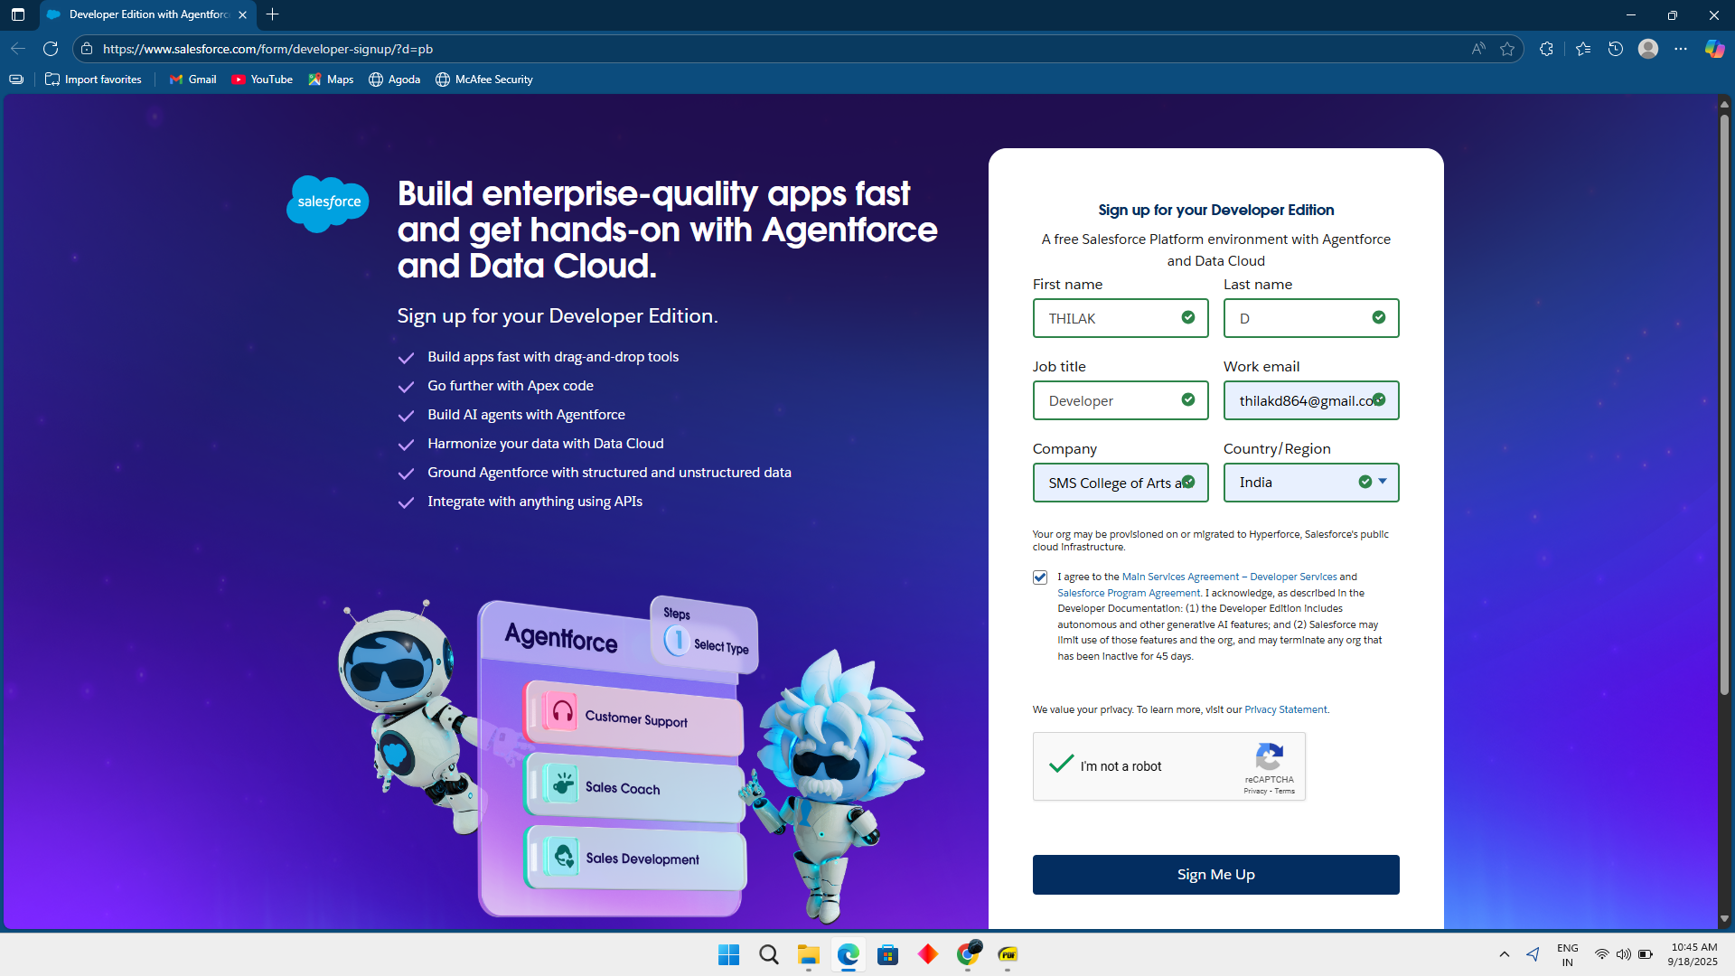

Account activation then next login this link

<https://login.salesforce.com/>

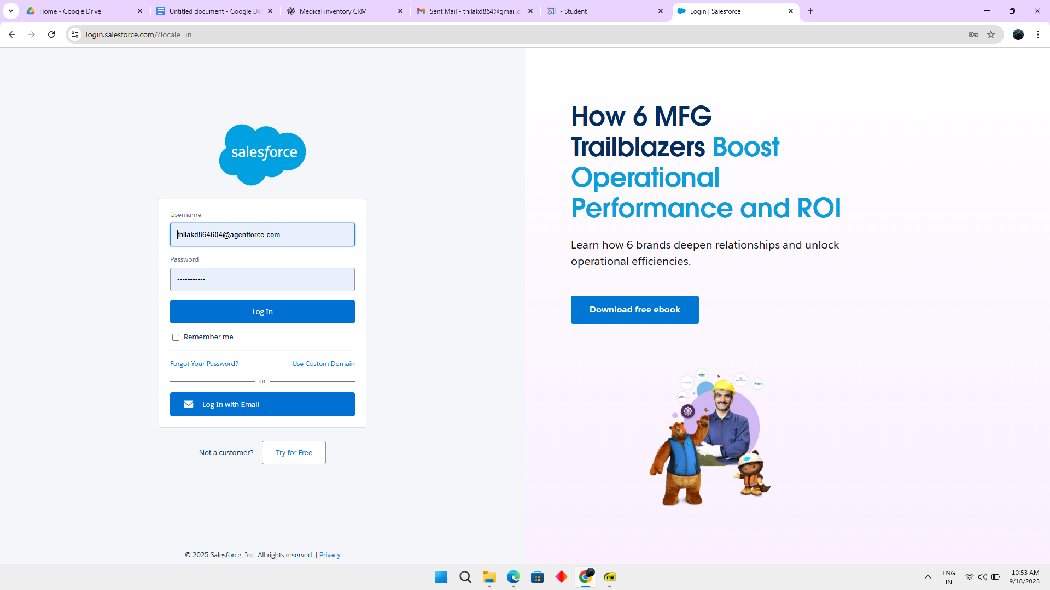

### **Objects**

In Salesforce, objects are database tables that allow you to store data specific to your organization.

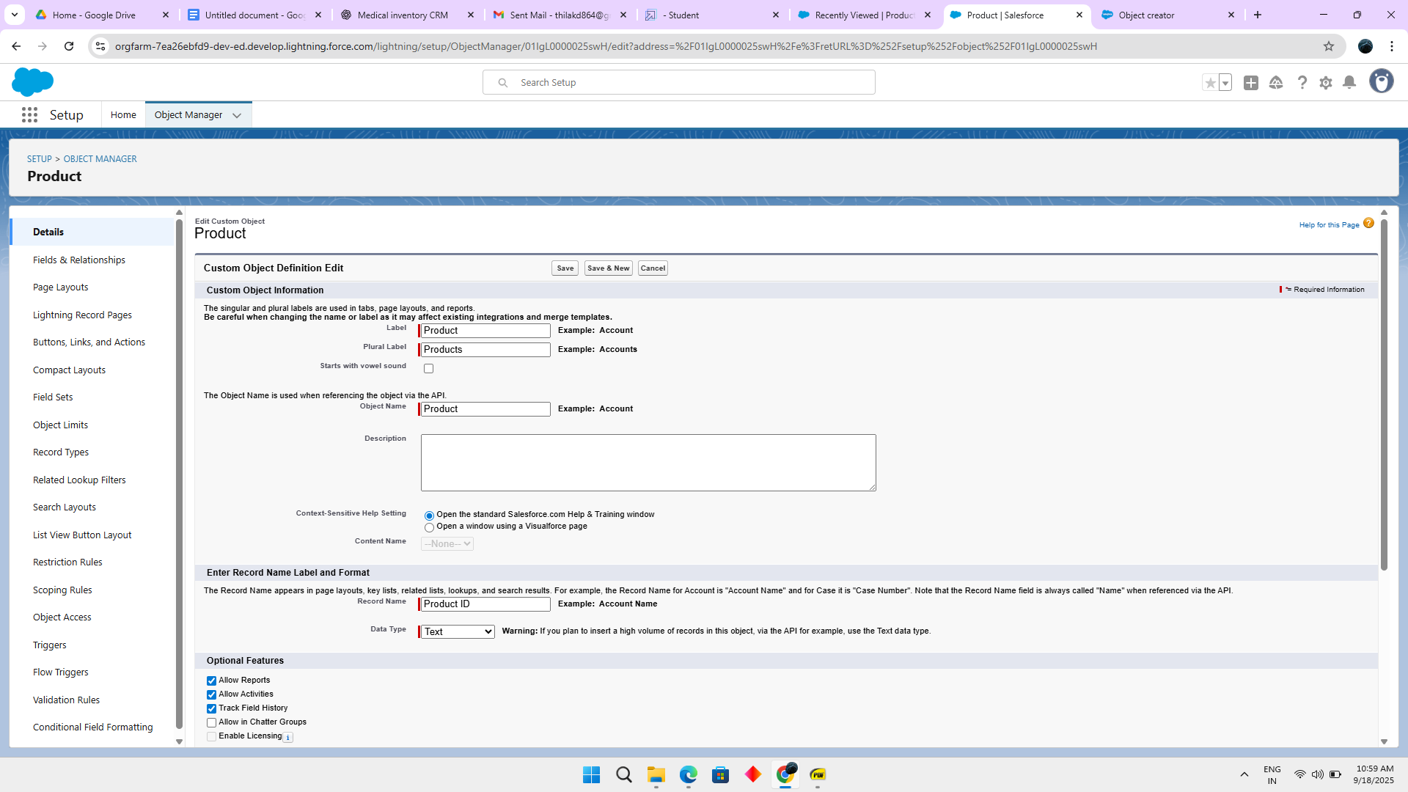

### **Tabs**

In Salesforce, tabs are used to make the data stored in objects accessible to users through the user interface. Tabs are a fundamental part of the Salesforce interface, providing a way to navigate to different objects and records.

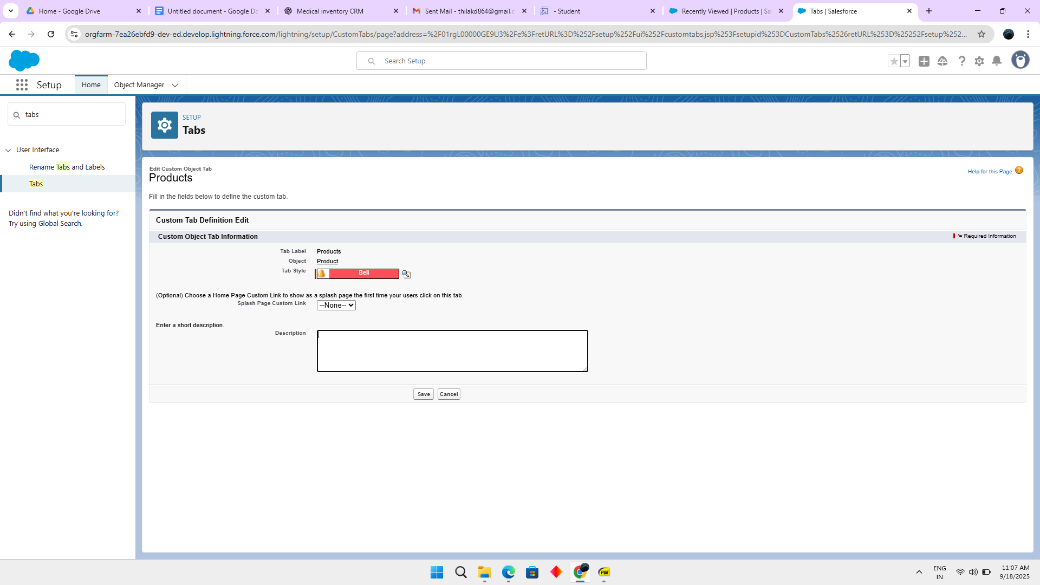

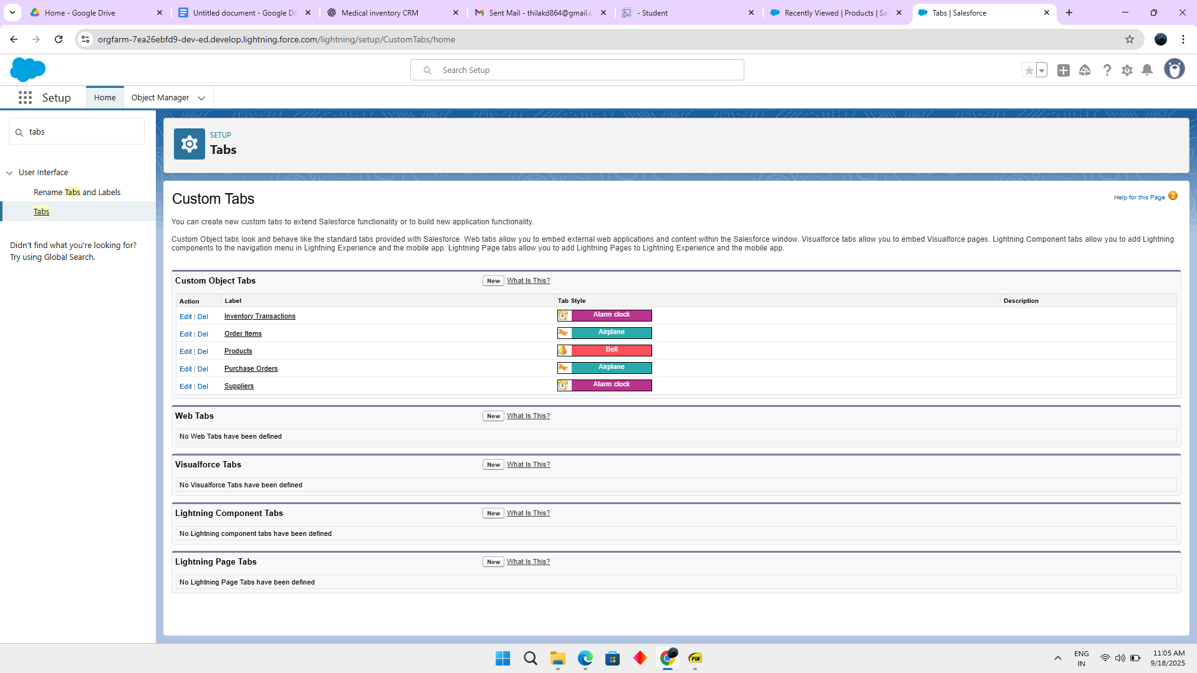

### **The Lightning App**

A Lightning App in Salesforce is a collection of items that work together to serve a particular function for the end-users. These items can include standard and custom objects, tabs, utilities, and other productivity tools. Lightning Apps are designed to provide a more intuitive and efficient user experience compared to traditional Salesforce apps.

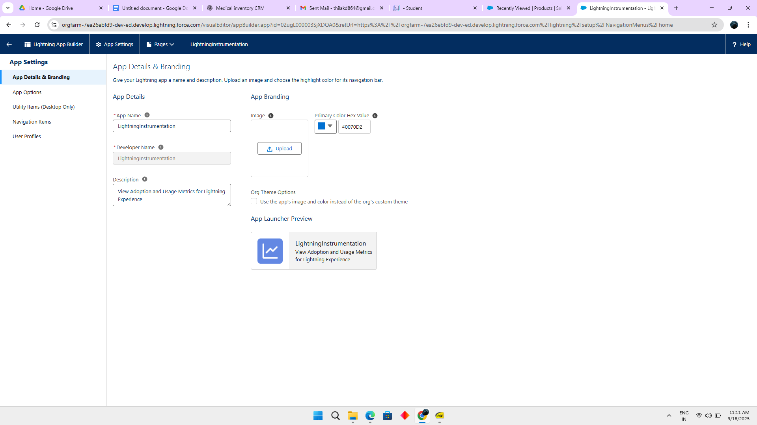

**Fields**

Fields in the Medical Inventory Management CRM capture key details like stock name, quantity, expiry, supplier info, and usage logs. These fields ensure accurate tracking, automation, and reporting for better inventory control.

1.**Product Object**

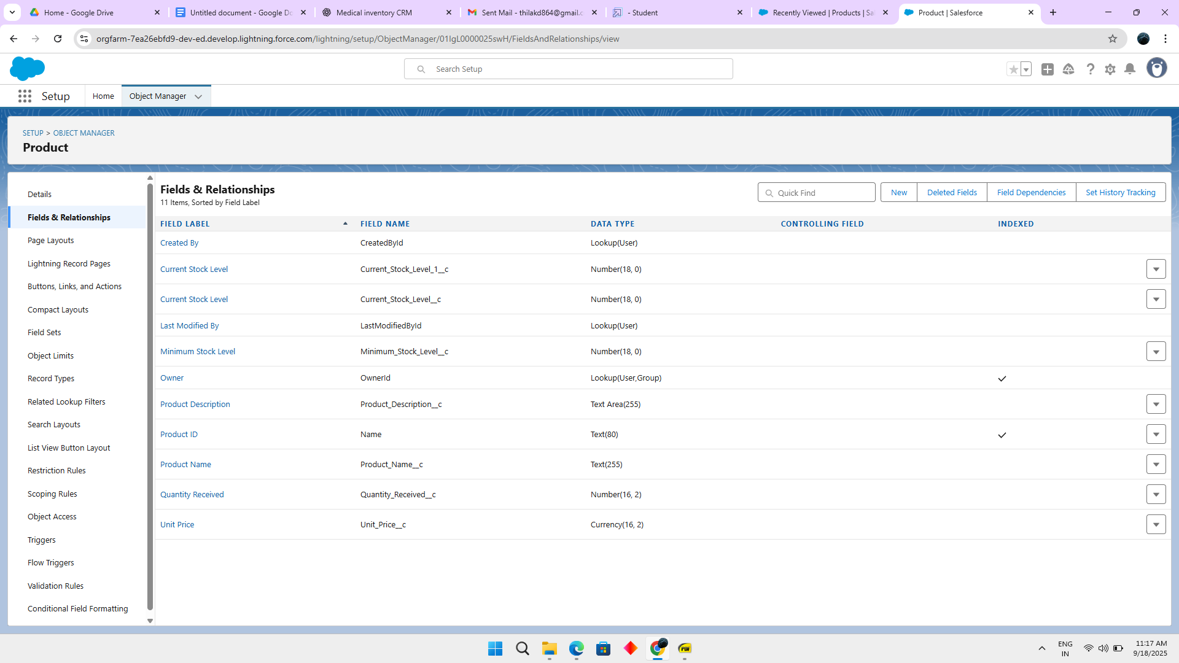

2.**Purchase Order Object**

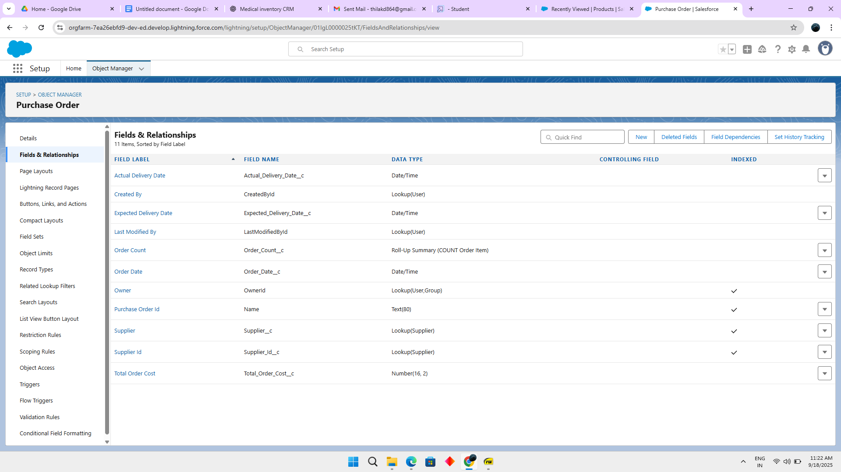

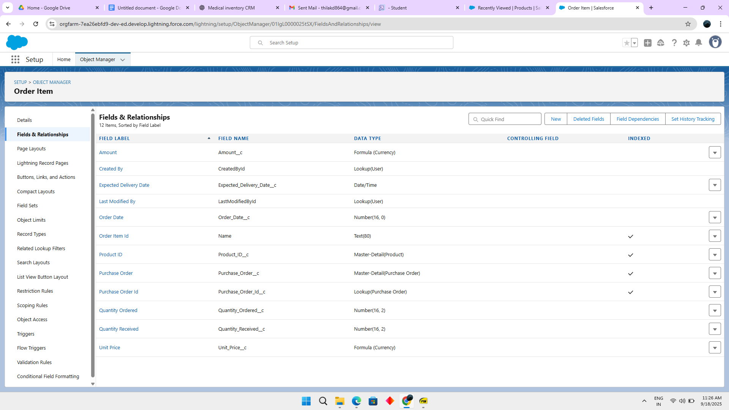

4.**Inventory Transaction Object**

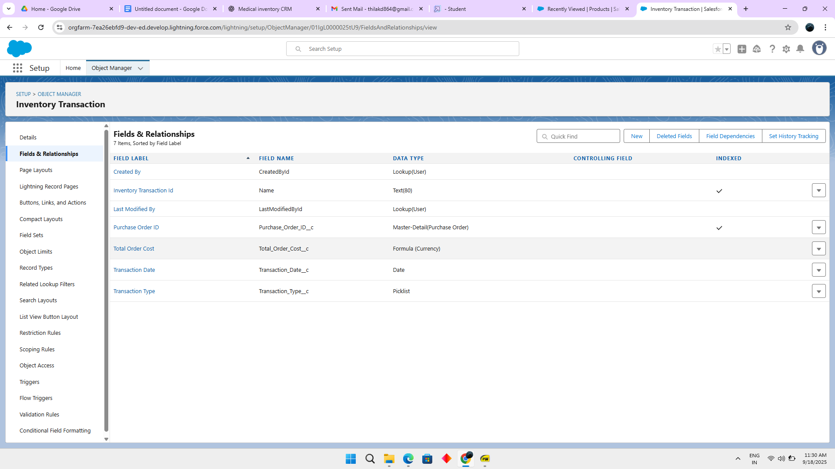

**5.Supplier object**

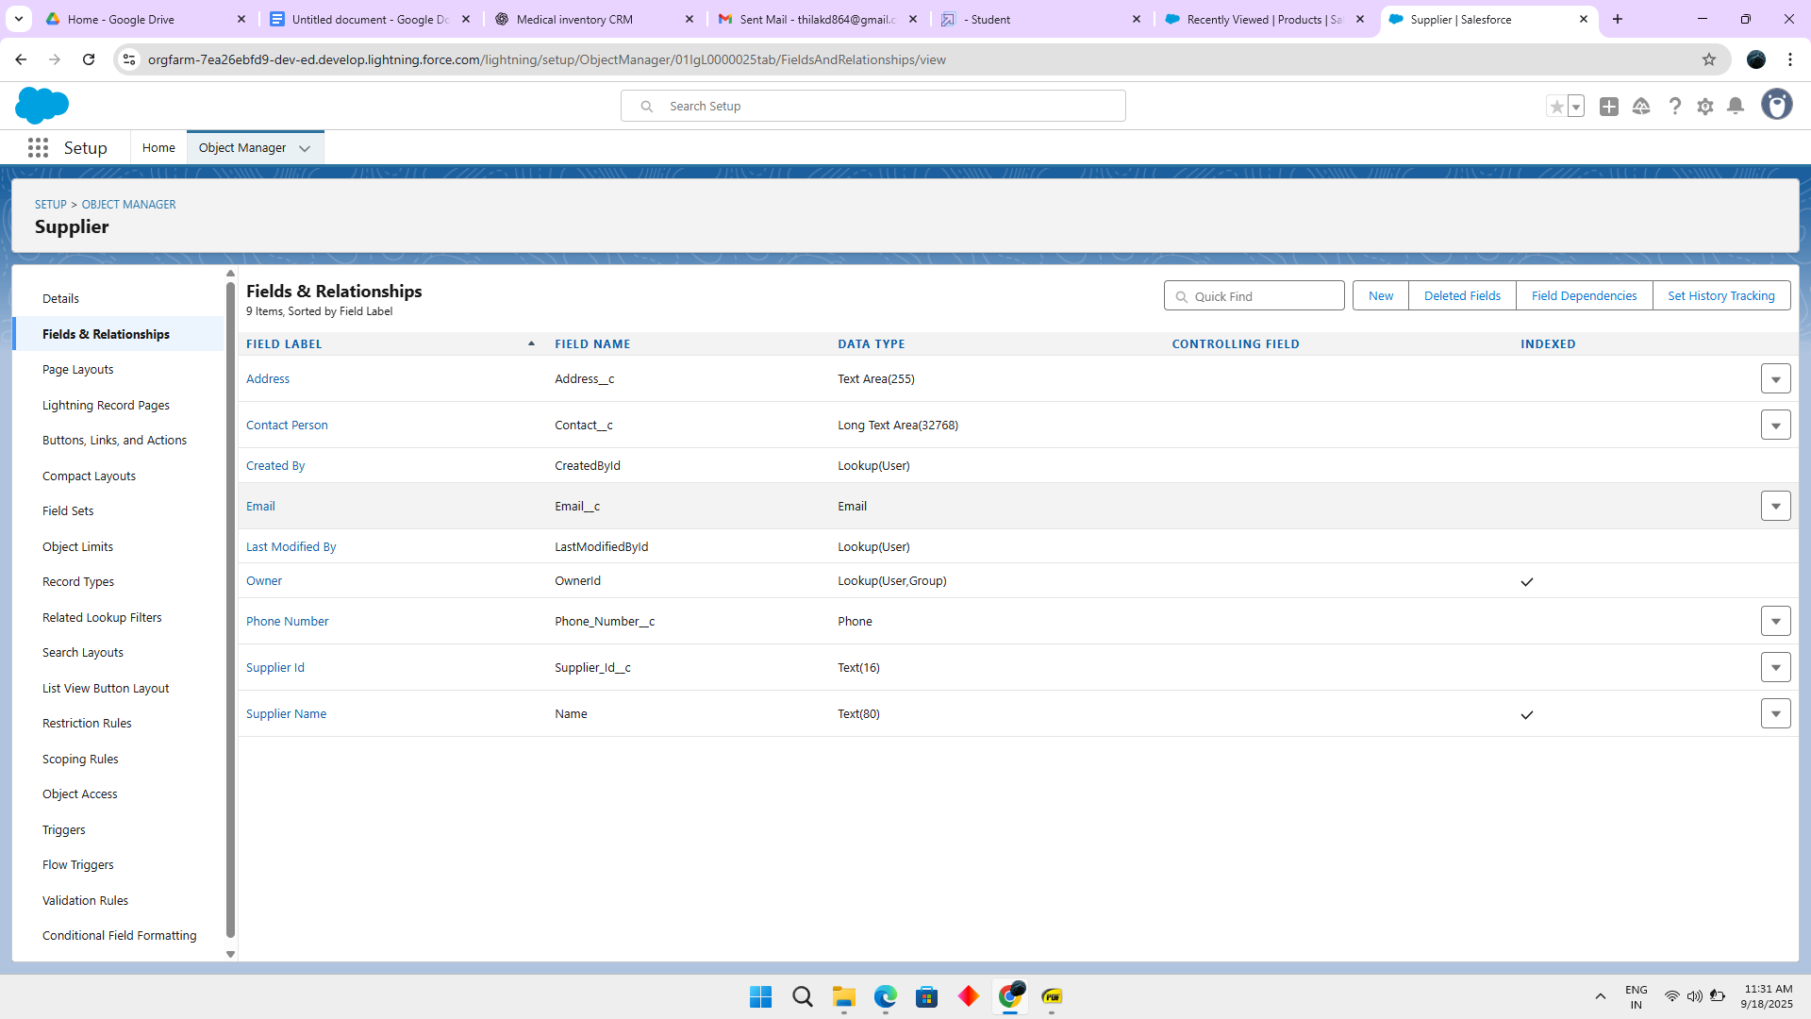

### **To edit a Page Layout**

### **1.Product Object**

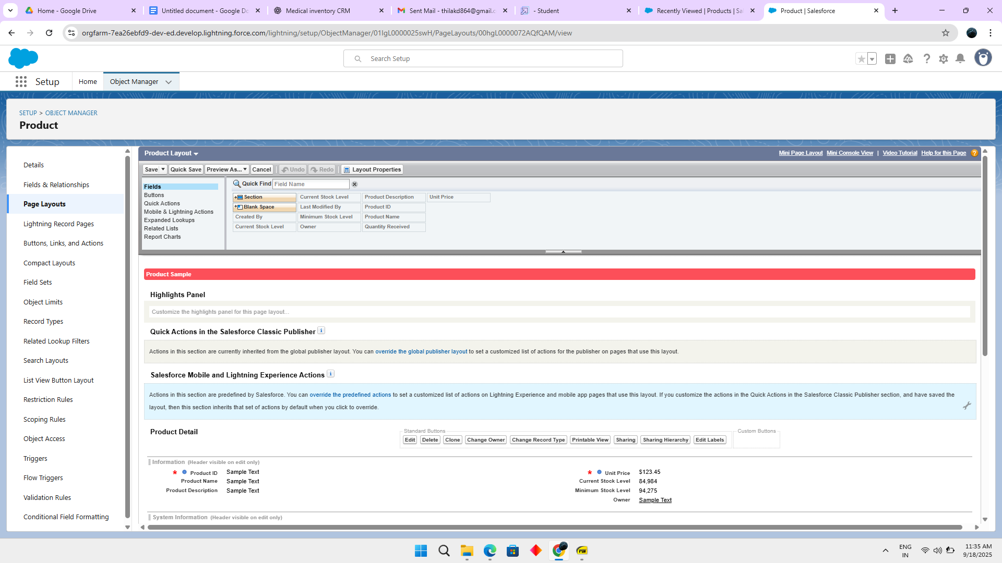

### **2.Purchase Order Object**

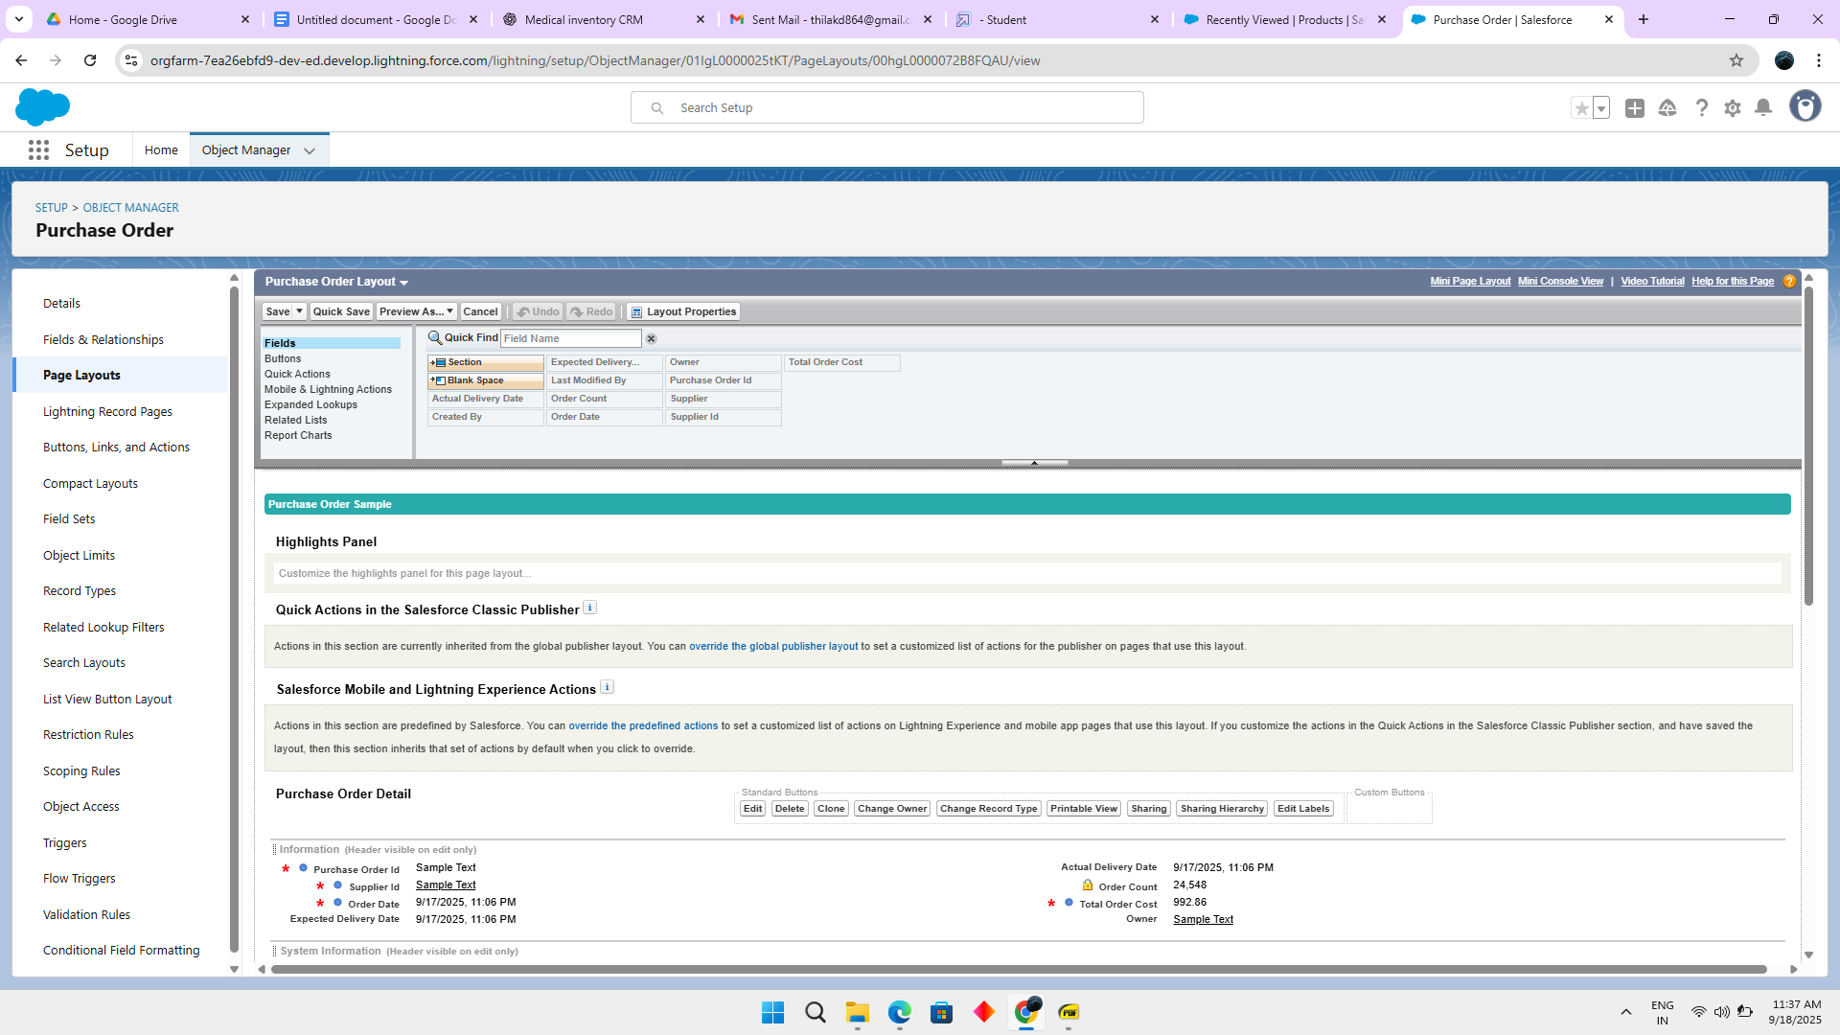

3.**Order Item Object**

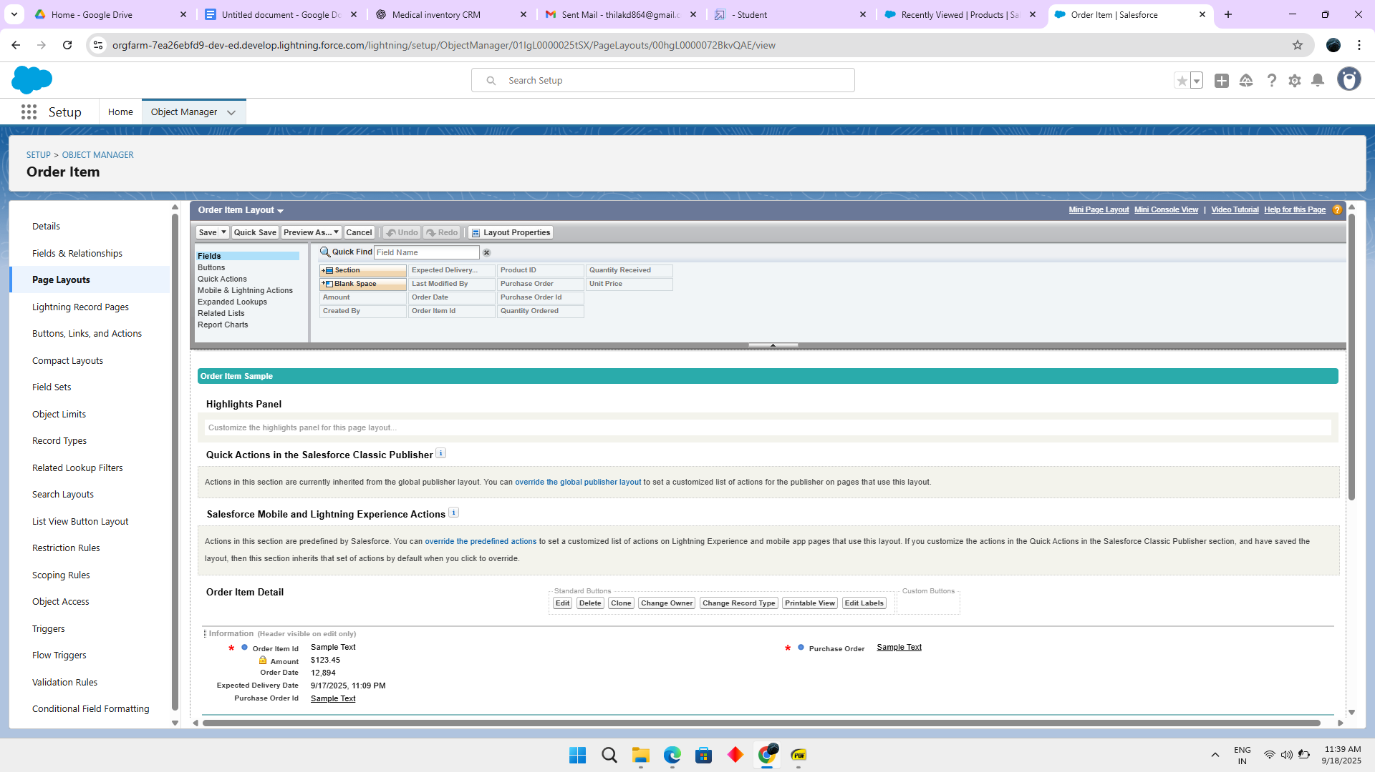

### **4.Inventory Transaction Object**

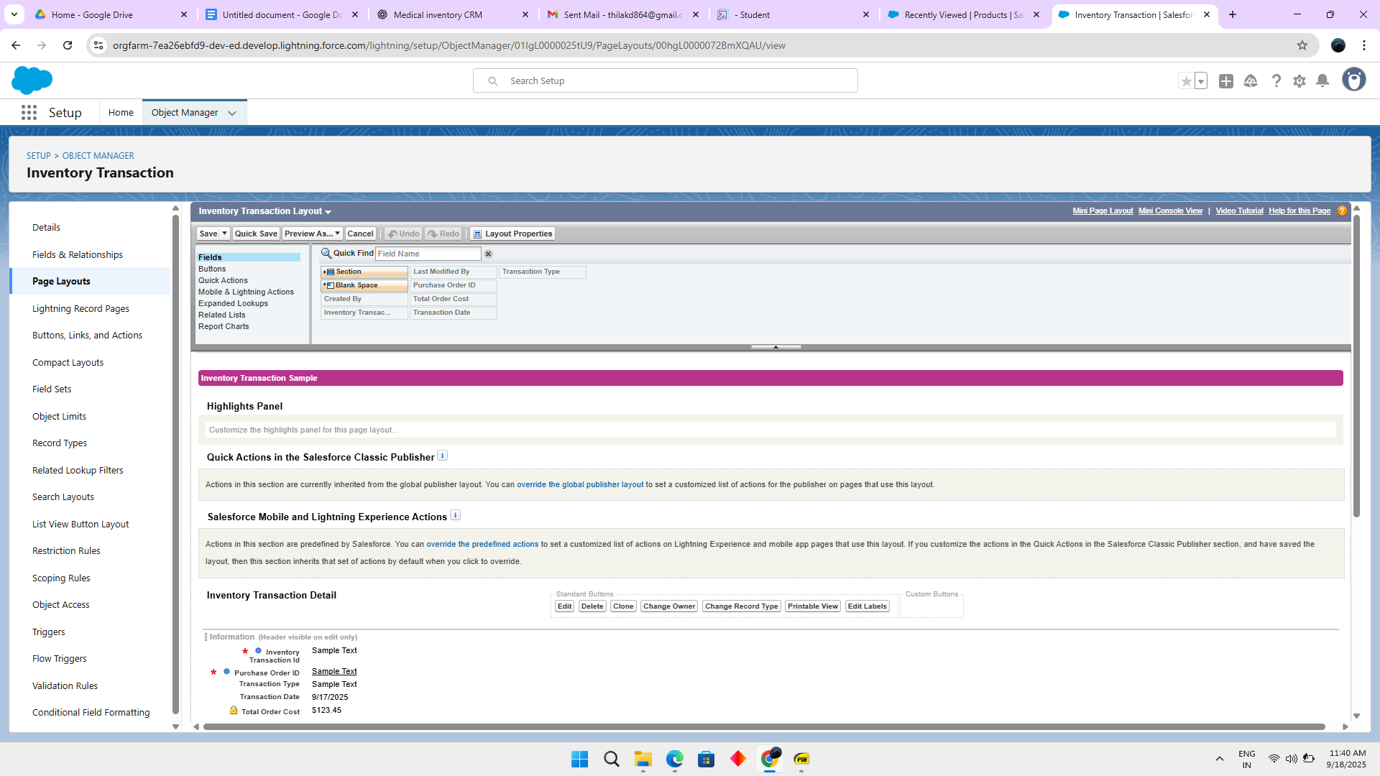

### **5.Supplier Object**

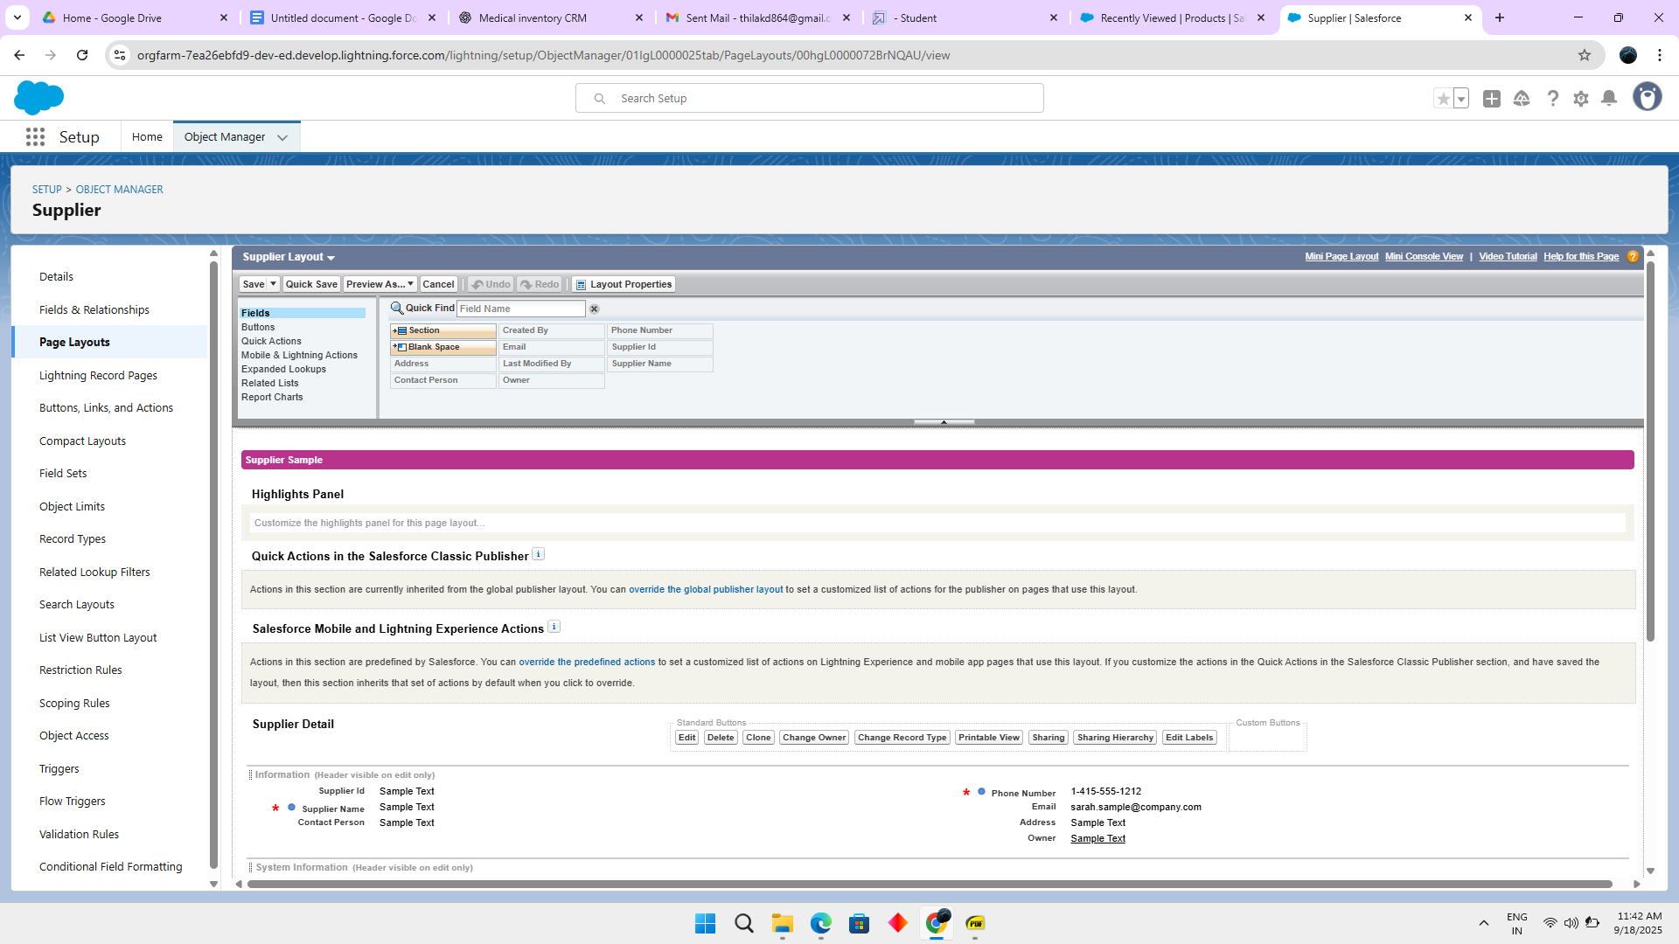

### **create a Compact Layout**

1.**Product Object**

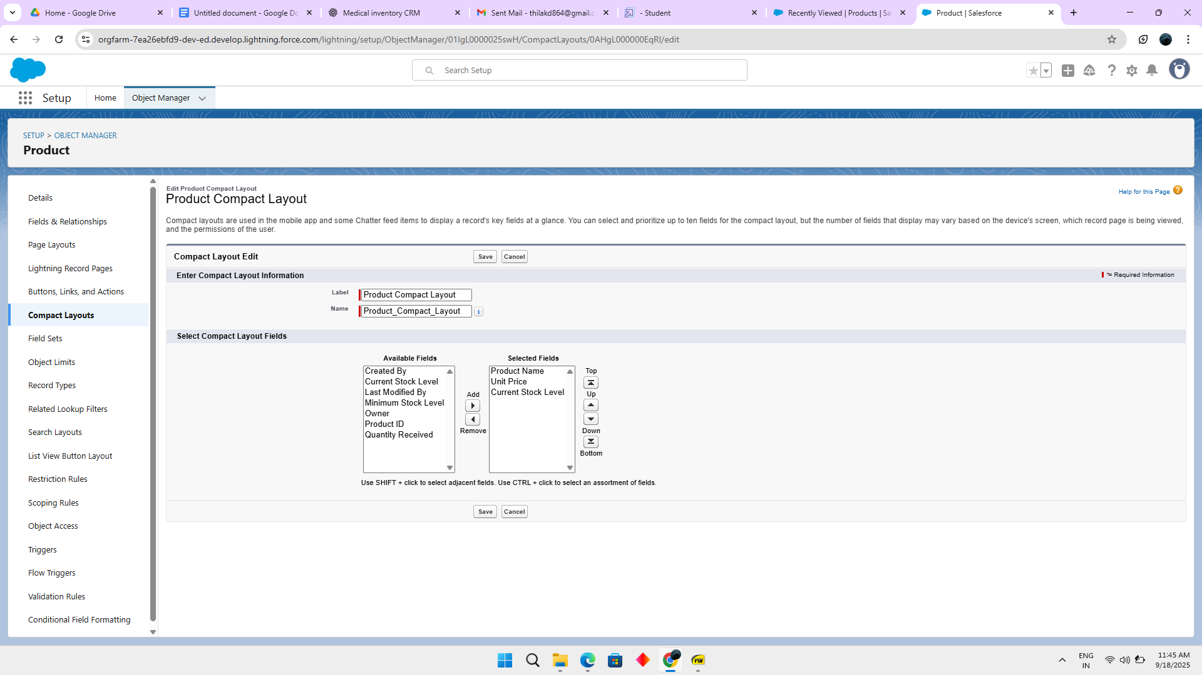

**2.Purchase Order Object**

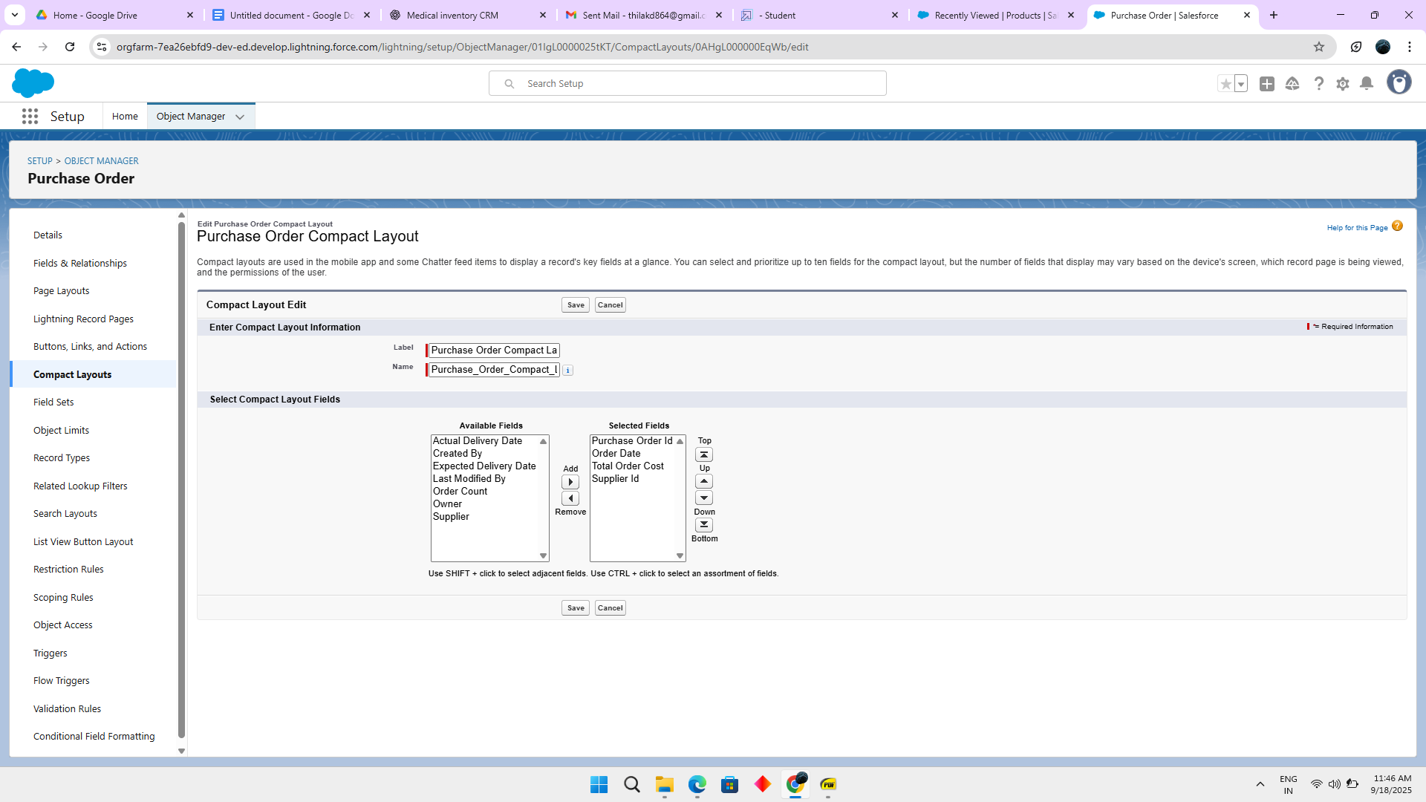

### 

### **Validation Rules**

### **Purchase Order Object**

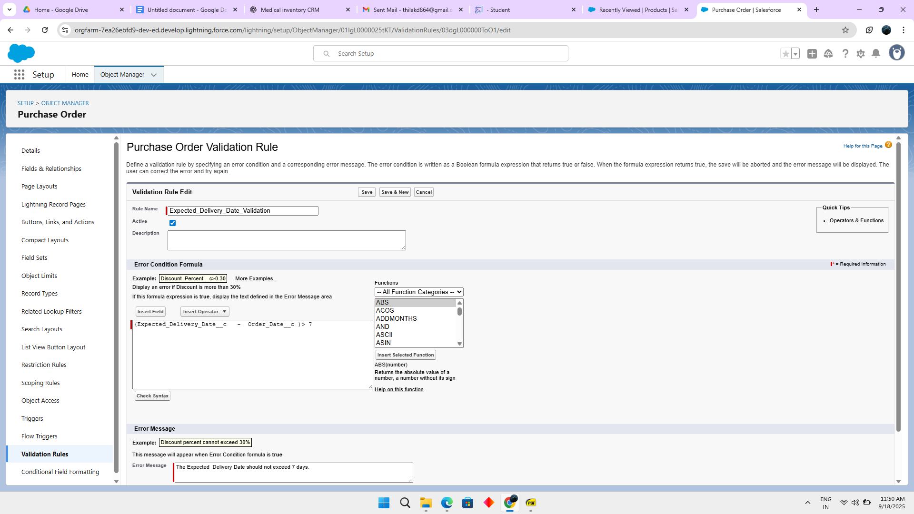

### **Profile**

### Profiles in Salesforce are fundamental to the platform's security model, defining what users can do within the organization. Profiles control a user’s permissions to objects, fields, tabs, apps, and other settings. Each user in Salesforce must be assigned a profile, and the profile assigned to a user determines what they can see and do in the system.

### **1. Inventory Manager Profile**

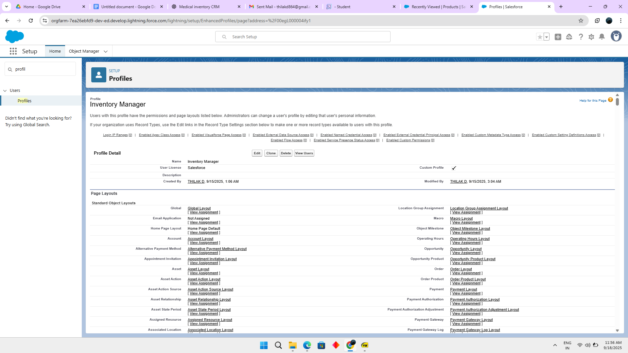

2.**Purchase Manager Profile**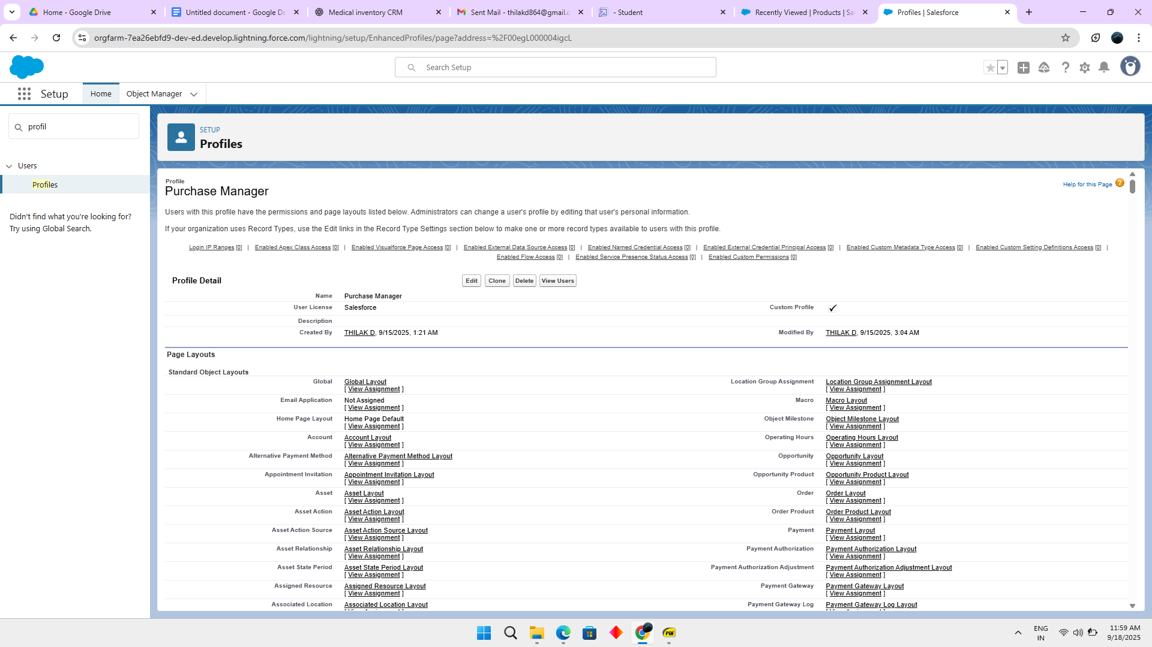

### 

### **Roles And Users**

Roles in Salesforce are used to control record-level access and define the hierarchy of an organization, determining the level of visibility and sharing of records among users. Roles work in conjunction with profiles to provide a robust security model. While profiles control what actions users can perform (object and field permissions), roles control which records users can see based on their position in the hierarchy.

**1.Purchasing Manager Role**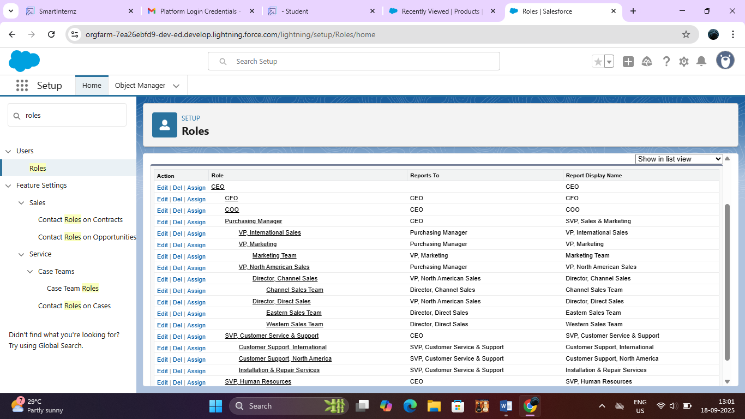

### 2.**Inventory Manager Role**

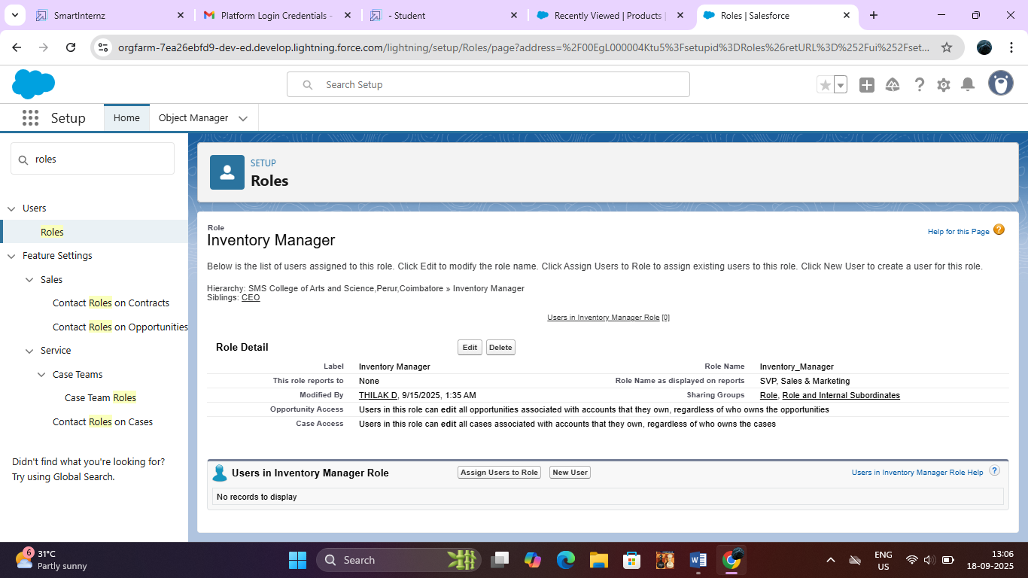

### **3.Purchasing Manager User**

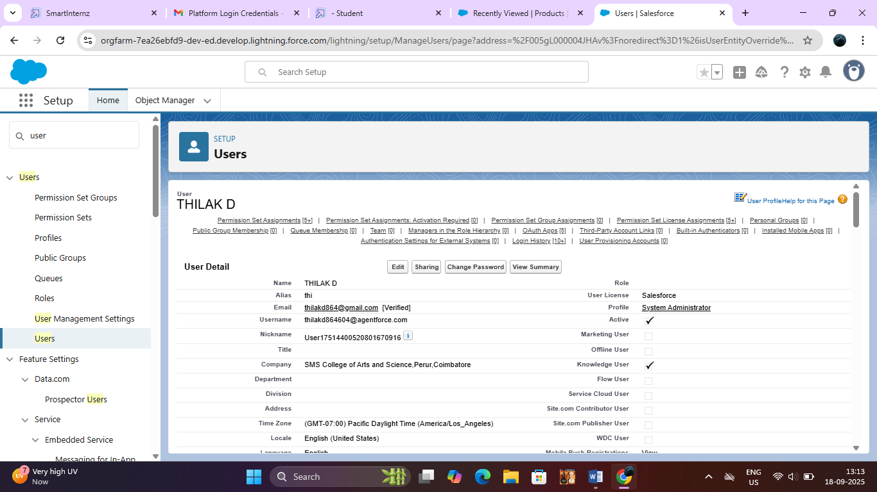

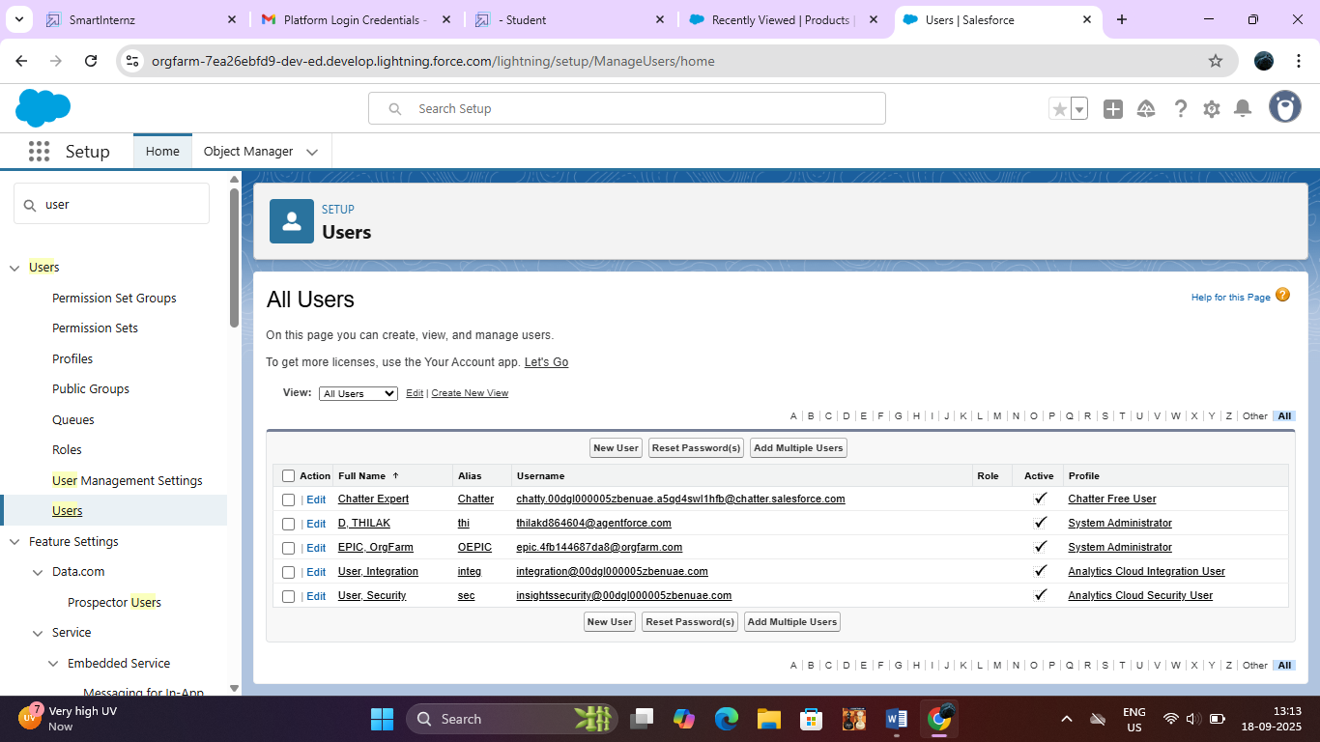

### **Permission Sets**

### 

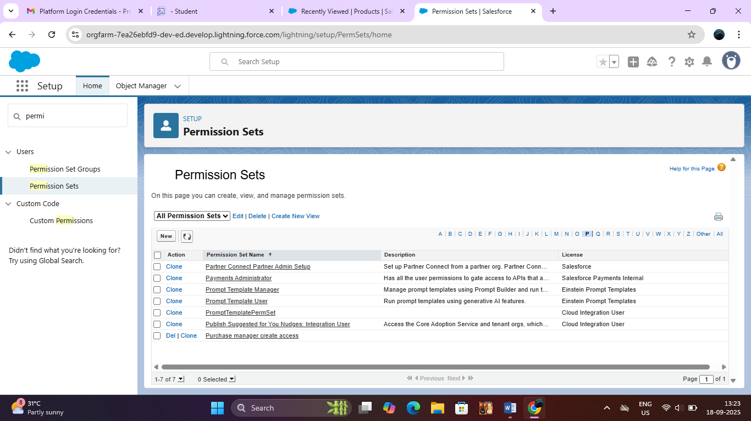

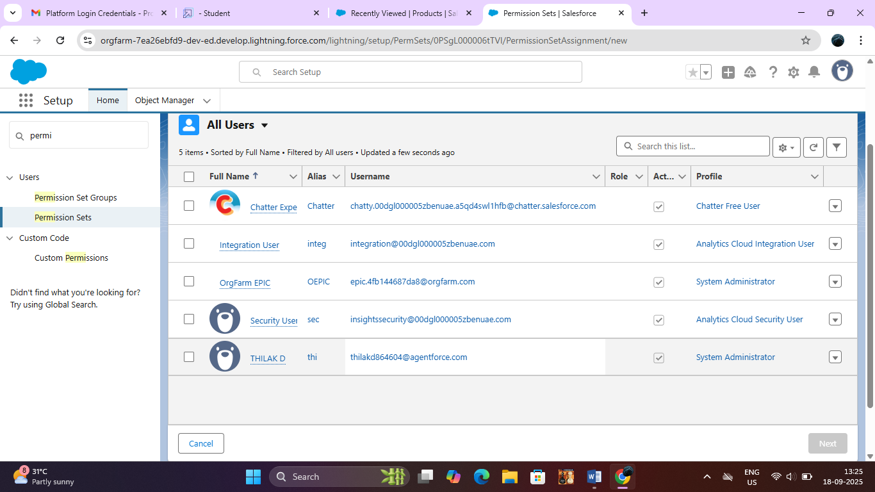

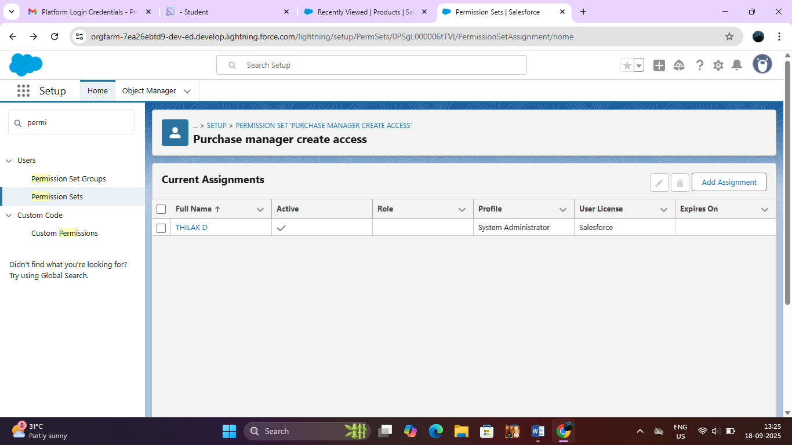

### **Flows**

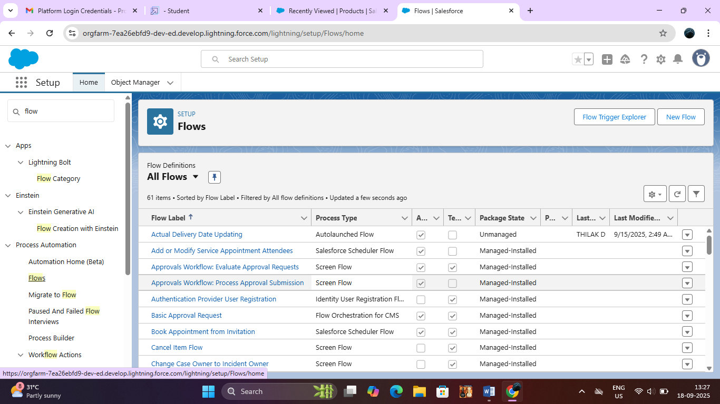

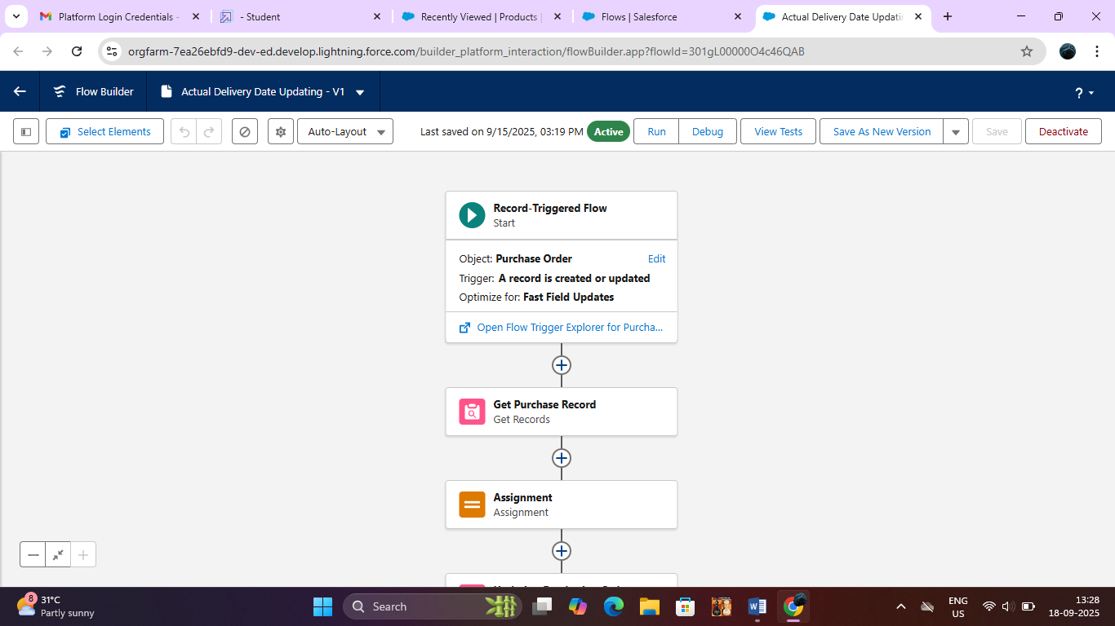

**Triggers**

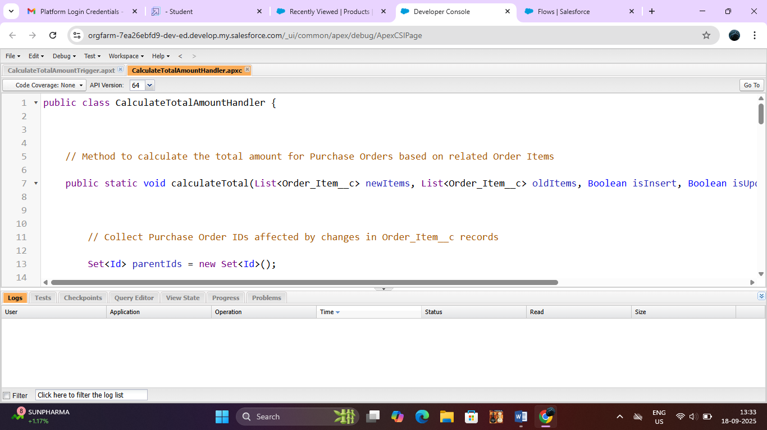

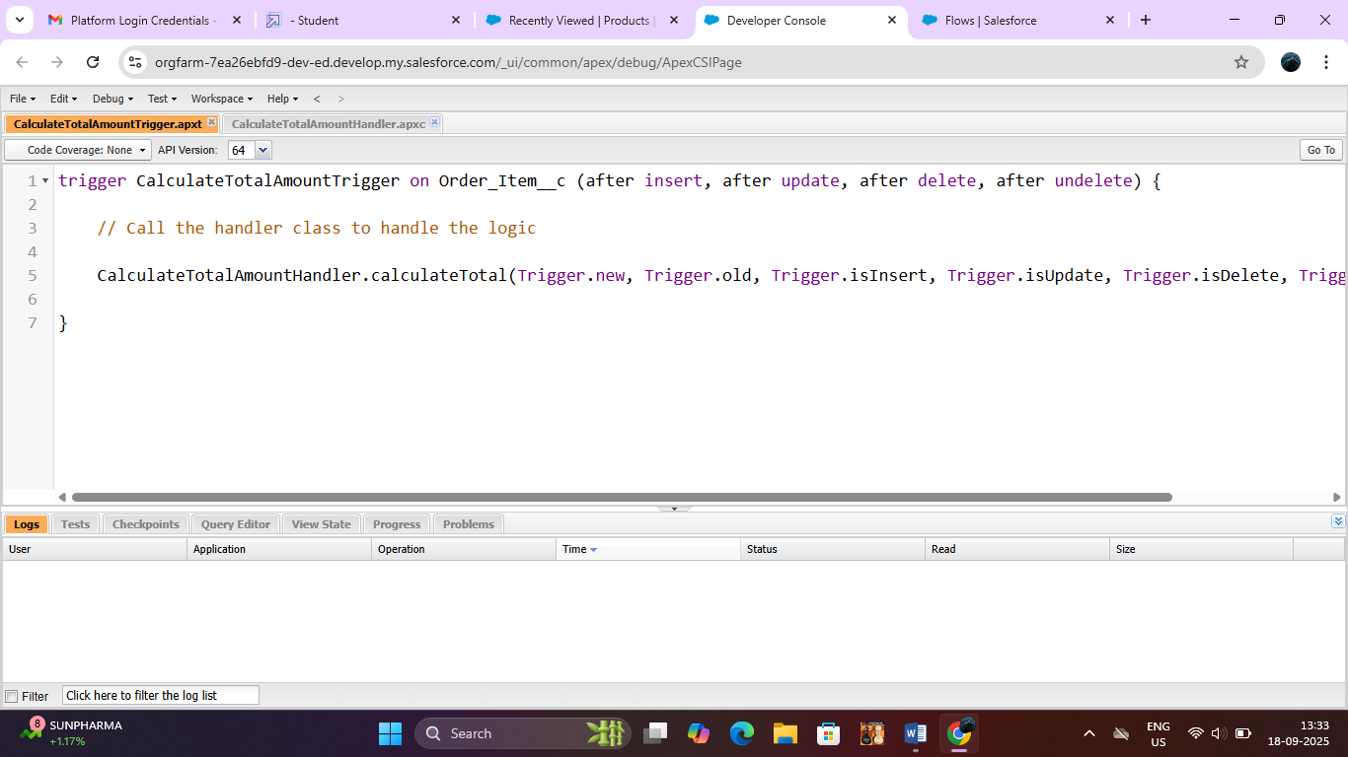

### **Reports**

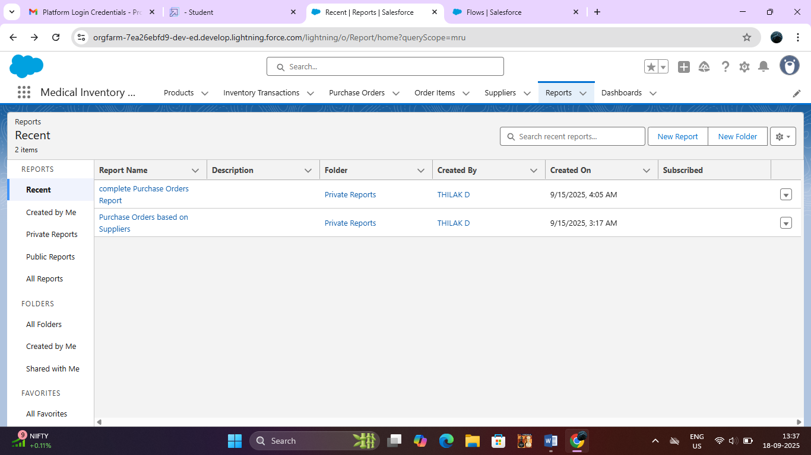

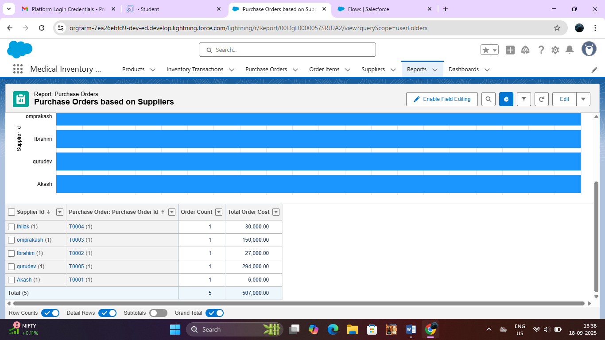

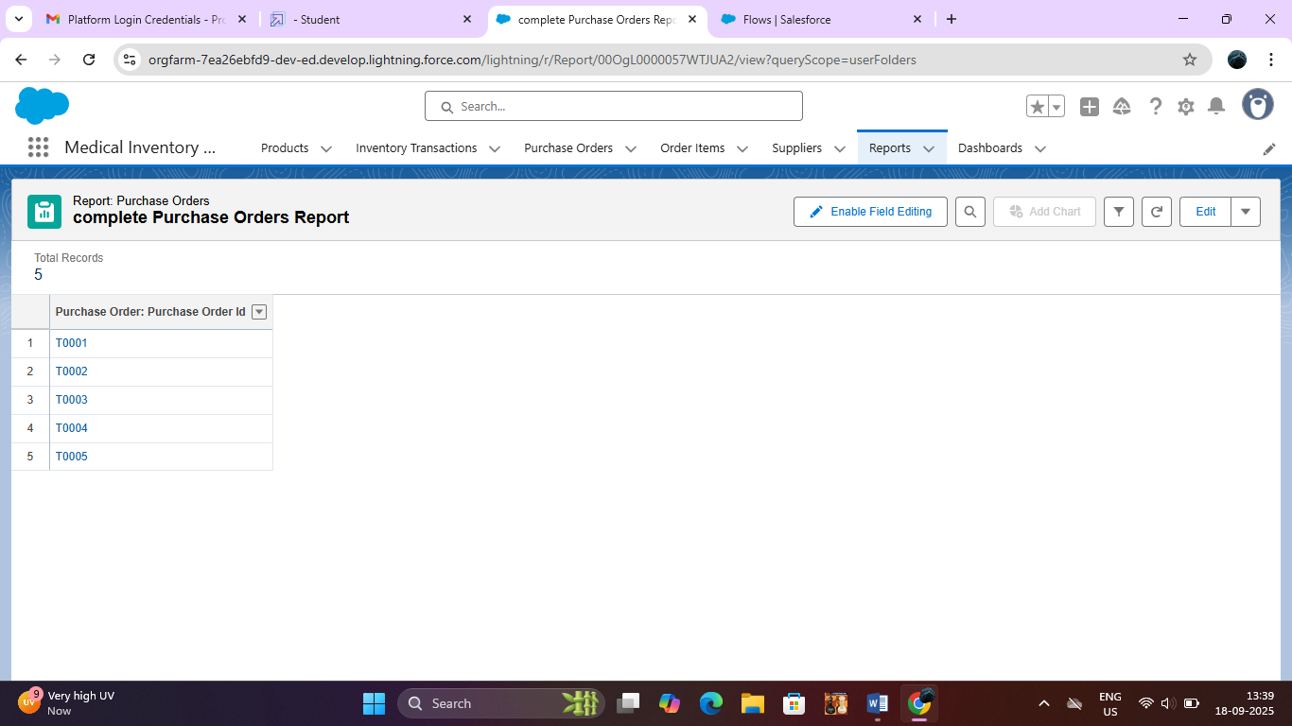

### **Dashboards**

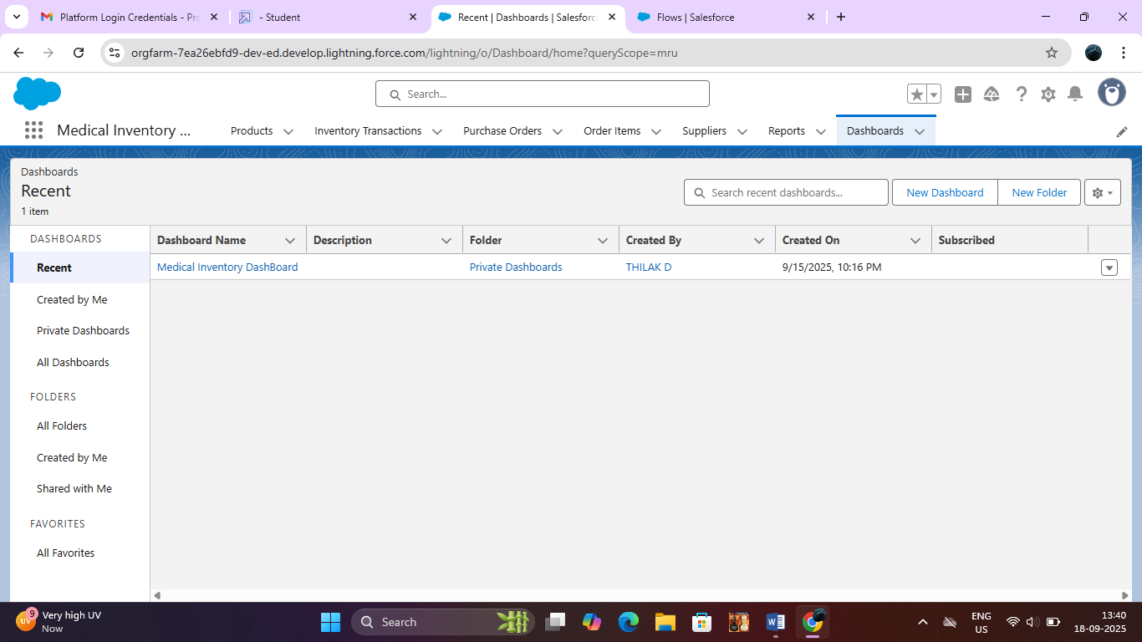

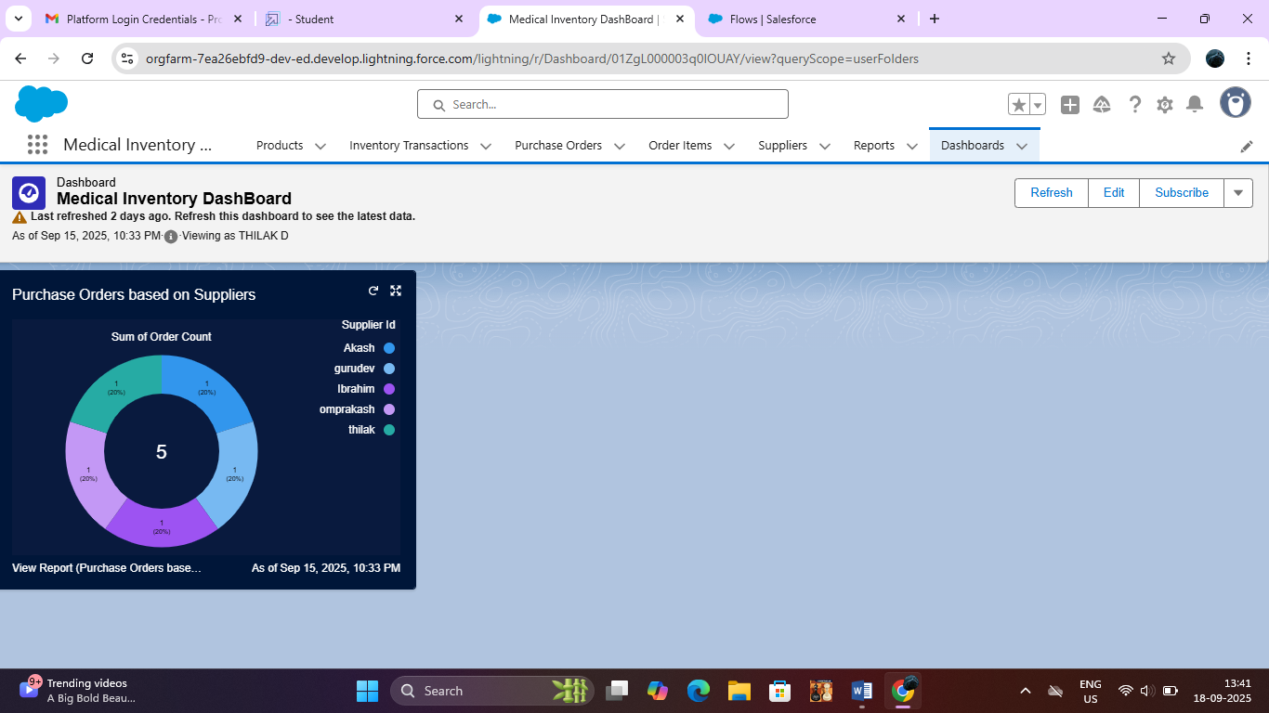

**ADVANTAGES:**

**Real-Time Inventory Tracking:**

Enables instant visibility into stock levels and item movement across multiple locations.

**Automation of Reordering:**

Automatically creates purchase orders and sends alerts when stock falls below the defined threshold.

**Regulatory Compliance:**

Helps maintain records for audits with validation rules, expiration tracking, and reporting.

**Improved Supplier Management:**

Centralized supplier information improves communication and tracking of order performance.

**Data-Driven Decision Making:**

Dashboards and reports provide insights into usage trends, enabling better forecasting.

**Scalability:**

Built on Salesforce, the system can easily scale and integrate with other business applications.

**Disadvantages:**

**Initial Setup Complexity**:

Custom object creation, flows, and configurations may require expert Salesforce knowledge.

**Training Requirement:**

Users may need training to fully utilize system features and navigate Salesforce efficiently.

**Dependence on Internet/Cloud:**

As a cloud-based system, functionality depends on stable internet connectivity.

**Customization Costs:**

Further customization, integrations, or advanced features (like AI) may increase project costs.

**Create an Apex Trigger:**

trigger CalculateTotalAmountTrigger on Order_Item__c (after insert, after update, after delete, after undelete) {

    // Call the handler class to handle the logic

    CalculateTotalAmountHandler.calculateTotal(Trigger.new, Trigger.old, Trigger.isInsert, Trigger.isUpdate, Trigger.isDelete, Trigger.isUndelete);

}

 public class CalculateTotalAmountHandler {

    // Method to calculate the total amount for Purchase Orders based on related Order Items

    public static void calculateTotal(List<Order_Item__c> newItems, List<Order_Item__c> oldItems, Boolean isInsert, Boolean isUpdate, Boolean isDelete, Boolean isUndelete) {

        // Collect Purchase Order IDs affected by changes in Order_Item__c records

        Set<Id> parentIds = new Set<Id>();

        // For insert, update, and undelete scenarios

        if (isInsert || isUpdate || isUndelete) {

            for (Order_Item__c ordItem : newItems) {

                parentIds.add(ordItem.Purchase_Order_Id__c);

            }

        }

        // For update and delete scenarios

        if (isUpdate || isDelete) {

            for (Order_Item__c ordItem : oldItems) {

                parentIds.add(ordItem.Purchase_Order_Id__c);

            }

        }

        // Calculate the total amounts for affected Purchase Orders

        Map<Id, Decimal> purchaseToUpdateMap = new Map<Id, Decimal>();

        if (!parentIds.isEmpty()) {

            // Perform an aggregate query to sum the Amount__c for each Purchase Order

            List<AggregateResult> aggrList = [

                SELECT Purchase_Order_Id__c, SUM(Amount__c) totalAmount

                FROM Order_Item__c

                WHERE Purchase_Order_Id__c IN :parentIds

                GROUP BY Purchase_Order_Id__c

            ];

            // Map the result to Purchase Order IDs

            for (AggregateResult aggr : aggrList) {

                Id purchaseOrderId = (Id)aggr.get('Purchase_Order_Id__c');

                Decimal totalAmount = (Decimal)aggr.get('totalAmount');

                purchaseToUpdateMap.put(purchaseOrderId, totalAmount);

            }

            // Prepare Purchase Order records for update

            List<Purchase_Order__c> purchaseToUpdate = new List<Purchase_Order__c>();

            for (Id purchaseOrderId : purchaseToUpdateMap.keySet()) {

                Purchase_Order__c purchaseOrder = new Purchase_Order__c(Id = purchaseOrderId, Total_Order_cost__c = purchaseToUpdateMap.get(purchaseOrderId));

                purchaseToUpdate.add(purchaseOrder);

            }

            // Update Purchase Orders if there are any changes

            if (!purchaseToUpdate.isEmpty()) {

                update purchaseToUpdate;

            }

        }

    }

}

**CONCLUSION:**

The Medical Inventory Management CRM built on Salesforce has significantly improved the way healthcare facilities track, manage, and reorder medical supplies. By automating key workflows and providing real-time insights into inventory levels, the system has reduced stockouts, prevented overstocking, and ensured compliance with regulatory standards. The CRM provides a structured approach to procurement, inventory movement, and supplier management, ultimately contributing to improved operational efficiency and better patient care.